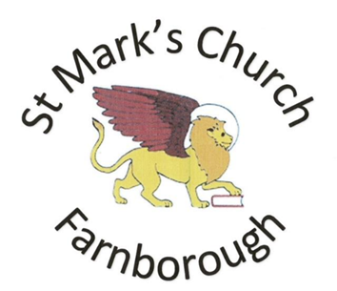
What’s on for the rest of the year 2022
Just some of the things we have planned, we hope you can join us.

July 9th
Open Church for Farnborough Food Bank 10am-1pm in the Church Garden
September 18th
Afternoon Tea Party (more information to follow)
September 24th
Open Church for MacMillan 10am-1pm in the Church Garden
October 15th
Harvest with Scarecrows and Ploughman’s Lunch
November 11th
Open Church Armistice Day 9.30 -1pm
November 19th
Open Church for Christmas Wreath Making for forthcoming Festival
November 27th – December 3rd Christmas Wreath Festival
November 27th
Festival Opens with Carols
During the week the Church will be open at various times. Come and see the displays and soak up the Advent Atmosphere.
December 3rd
Festival ends with Fair inside and out of the church (weather and space Permitting)
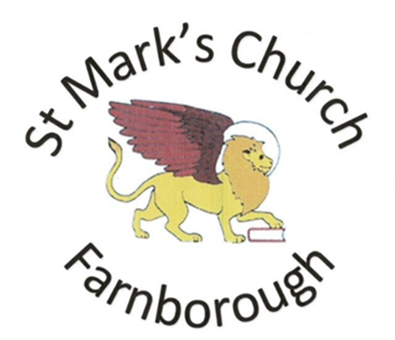
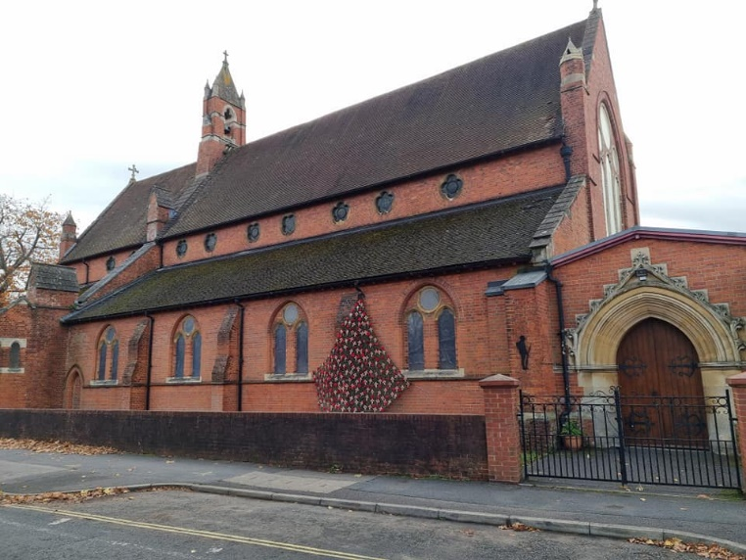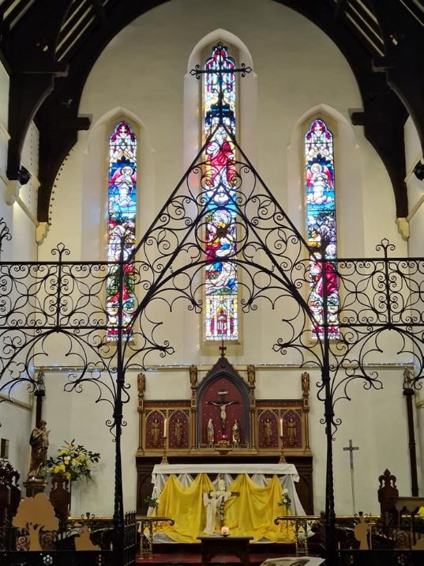
www.stmarksfarnborough.co.uk
Reading Rd, Farnborough GU14 6NA
Phone: 01252 544711
e-mail: stmarksfbro@outlook.com
Facebook: St. Marks Church Farnborough

First Sunday of the Month
8.00 Traditional Eucharist
8.48 Breakfast for all in Church Hall
10.30 All Age Service
Every Other Sunday 10.30 Service onley.
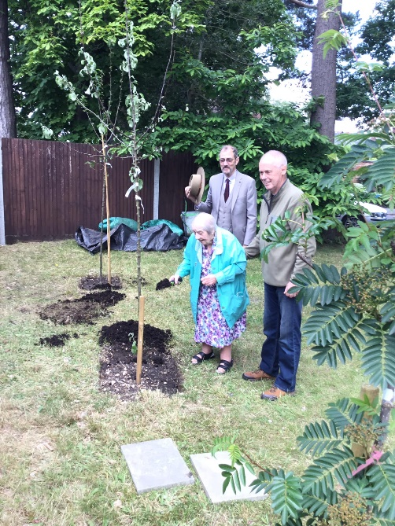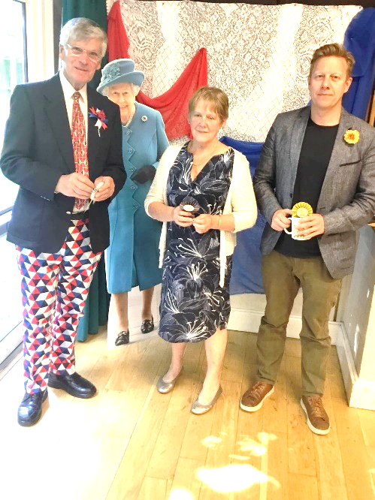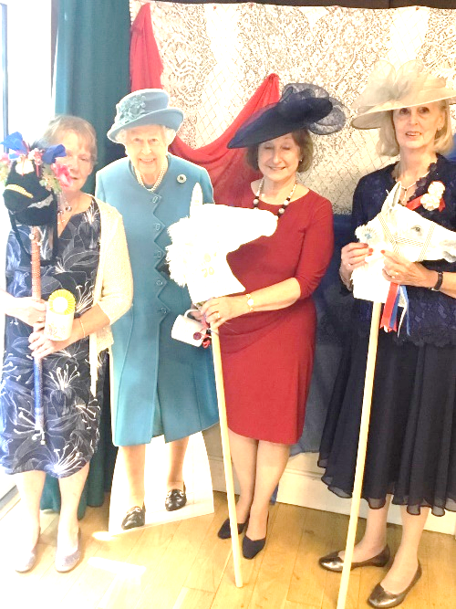
We Celebrated the Queens Jubilee with an Afternoon at the Races
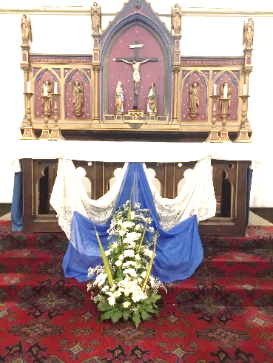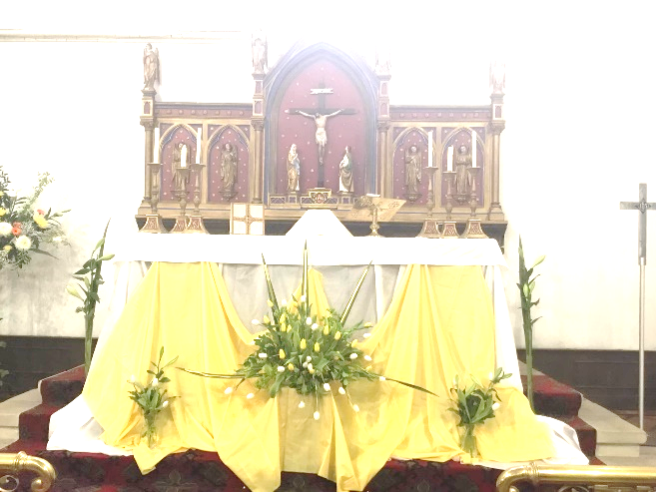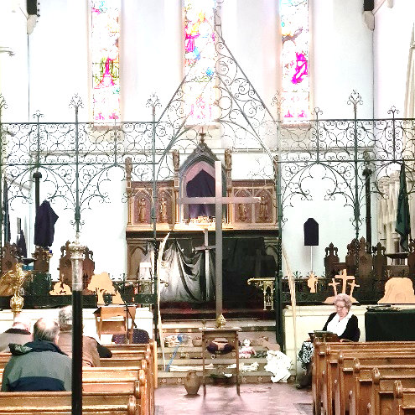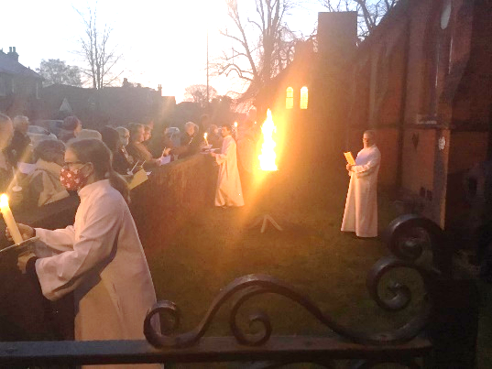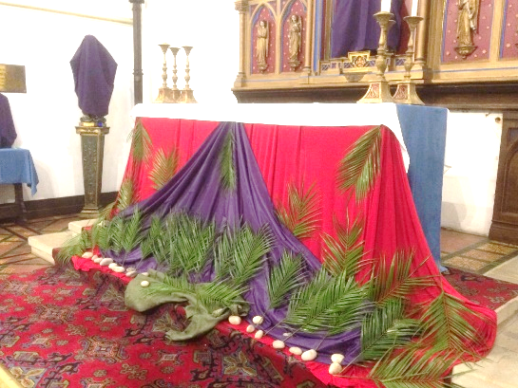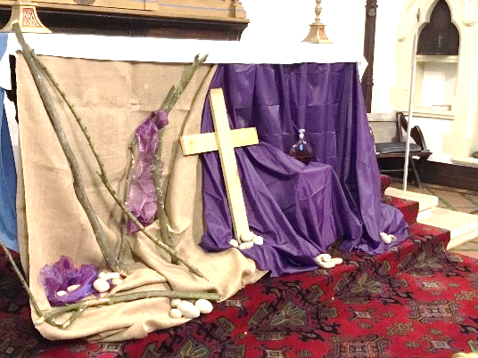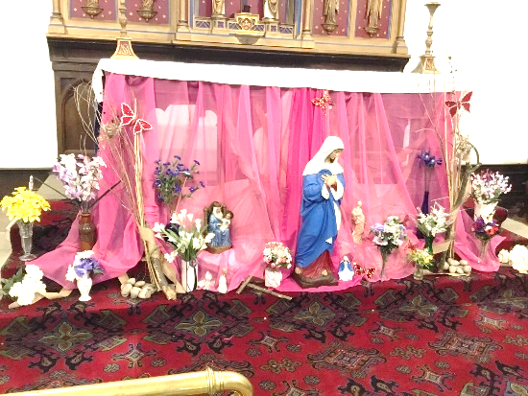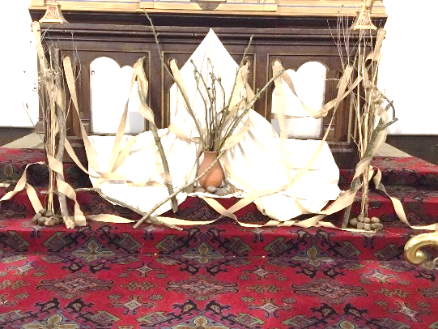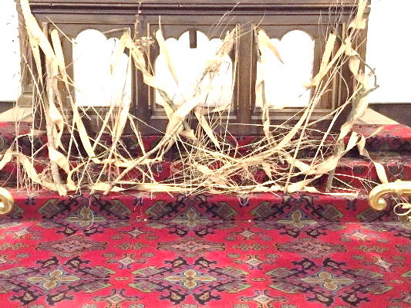
Over Lent and Easter, we Love to Decorate the Church and lots of things going on over Holy Week.
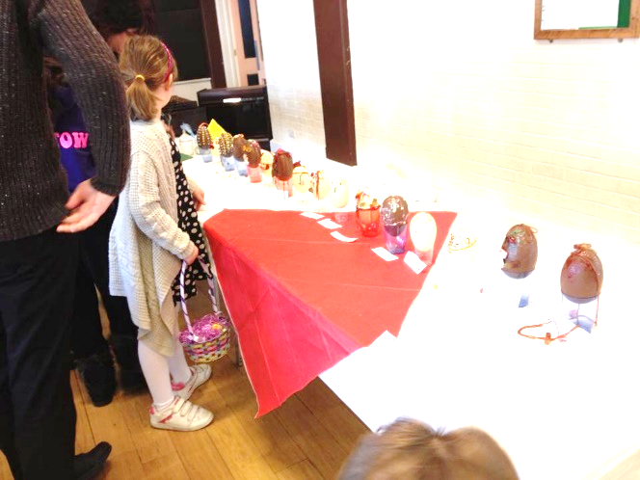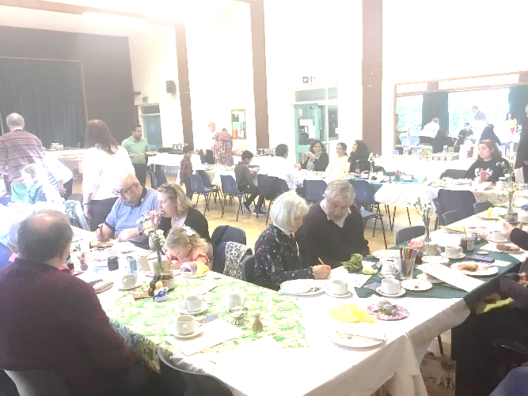
After the Dawn Easter Service we have a Big Breakfast, with lots to do like the Egg Decorating Competition and Egg Hunt.
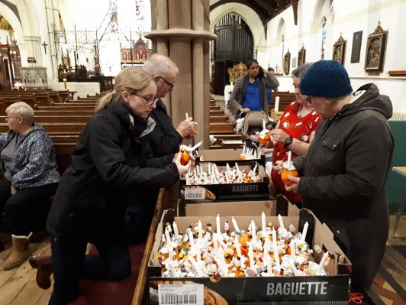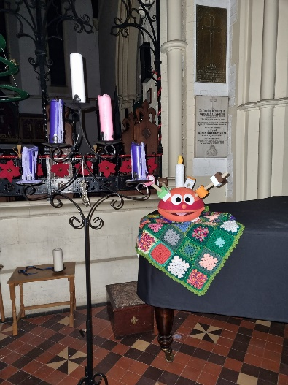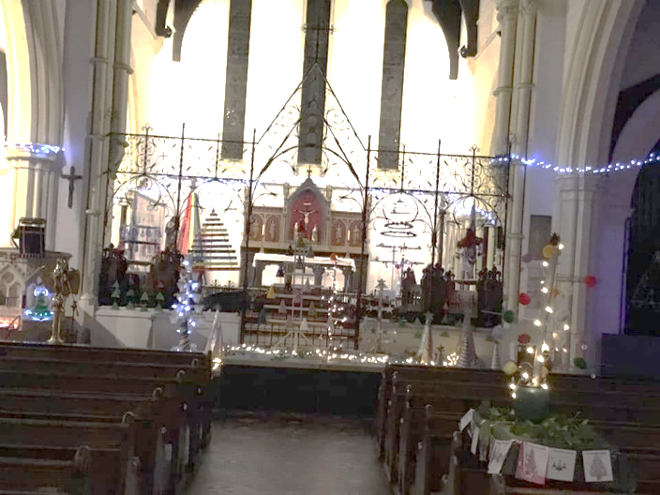
Over Christmas we have lots on from A Christmas Tree Festival to Christingle Service
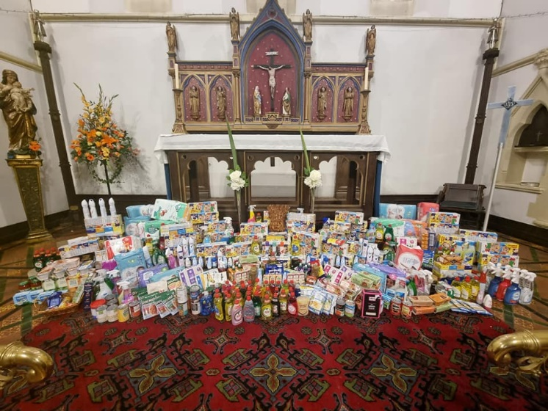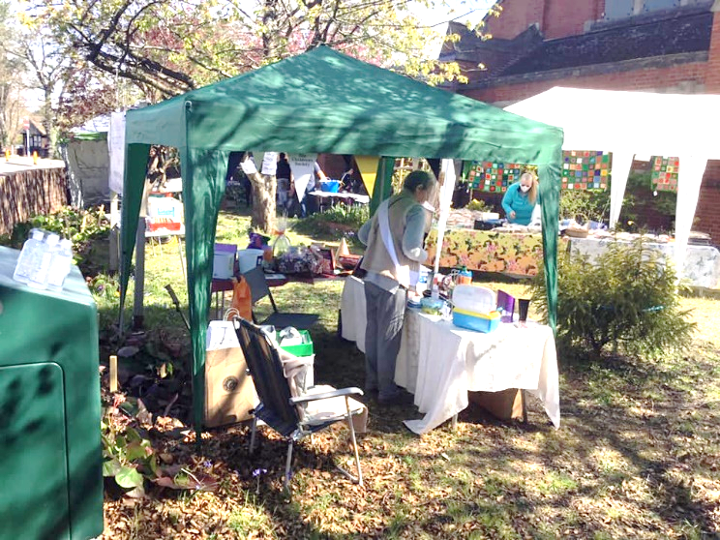
We Collected things for the Farnborough Food Bank at Harvest and had lots of fairs in the Church Garden. We always open for Remembrance events and Macmillan.
