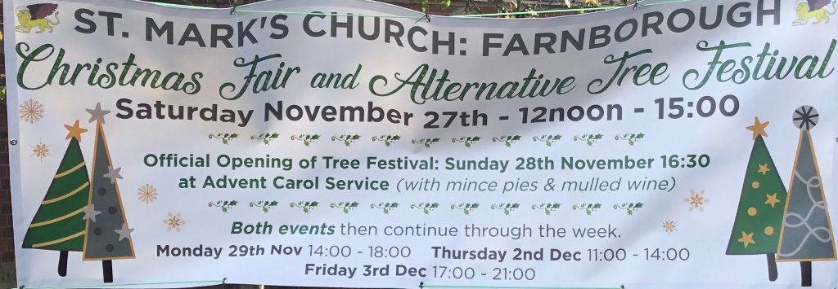
Well What better way to spread the word than by using the actual poster which is now displayed outside Church
Mammoth top quality Raffle
Cake Stall Jams and Chutneys
Refreshments Prize Every Time Tombola
Selfie Booth Children’s Lucky Dip
Wide variety of Hand Made goods
And Various other stalls.
All will be available during all of the opening times.
Looking forward to seeing you there.

